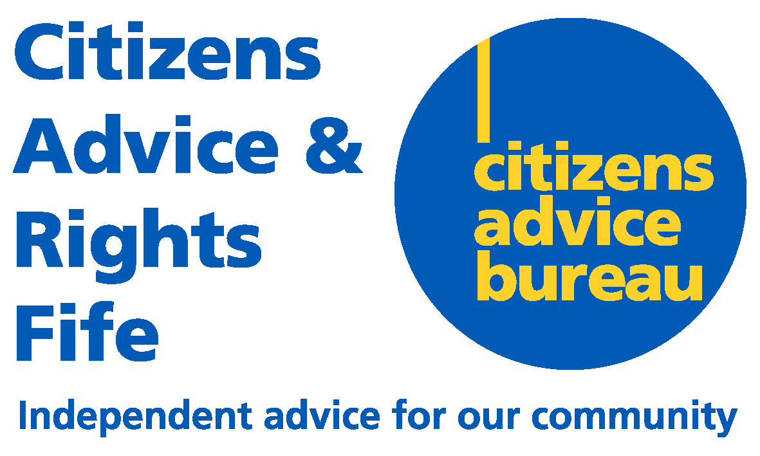 | Registered Office  Units 7 & 8  Craig Mitchell House  Flemington Road  Glenrothes  KY7 5QF  Telephone 0345 140 0095  www.cabfife.org.uk

CARF AGM 2022 – ALL WELCOME

Company Number: SC178060

NOTICE IS HEREBY GIVEN that the Twenty-fifth Annual General Meeting of Citizens Advice and Rights Fife Limited will be held on Wednesday 12th October 2022 at 1400 hours.

The Annual General Meeting will be held both physically, at Caledonia House, Pentland Park, Glenrothes, KY6 2AL and virtually this year. Anyone wishing to attend the AGM should contact Maureen Cooper, PA/Office Manager via email on mcooper@carfonline.org.uk no later than Tuesday 4th October advising of their preference to attend in person, or by Zoom platform. For those opting to join virtually, a Zoom link to the meeting will be sent prior to the event.

BY ORDER OF THE BOARD

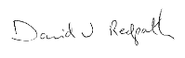

Company Secretary

